Online Book Store
Akshat Gupta
24BCE0607
Abstract
This website is an online book store. It can be used to purchase books (as long as purchase means adding to cart). Each title is interactive and can be individually clicked on, which will take the user to a page which provides the summary and rating of the book. The user lands on a login page, entering details will redirect him to the website. The website also has in built functionality for a cart to view which all books have been added to it, displaying the total value at the end, along with a contact form to be filled out in case of any grievances.

Introduction
You decided to grab that book to read again for old time’s sake and enjoyed it. Now that you are back into reading, you decided to order more books to read. But which website to order them from? Some take too long to fulfill the order; some don’t have that one you are looking for and others don’t have the best quality control. Look no further than Online Book Store, a one stop shop for the bookworms. It offers a wide range of books at fair prices with reliable delivery and a well-integrated shopping experience, making getting books for your reading journey a hassle-free task.

Motivation
As someone who enjoys reading in his free time and prefers physical copies of the same as supposed to e-books, I noticed that sometimes finding certain books in stock or finding them from a reputed seller at a fair price proved to be difficult. So I aimed to create a platform where customers can easily find the books at a fair price.

Problem Statement
Use HTML + CSS + JS to build a portal to browse books and add to cart, with the ability to view them in cart. Convert the same into a React application using the following:
- Components (Reusable structure)
- Props & PropTypes
- State management (useState)
- Side effects (useEffect)
- Routing

Existing System vs Proposed System
- There are already several e-commerce platforms (eg: Amazon, Flipkart,etc…) that stock books.
- The proposed plan for the website is to be dedicated to books, unlike other platforms. It will also include summaries and ratings for each book

System Specification
- The user lands on the login page, entering the fields will redirect to the website
- All CSS elements controlled using external style.css and all javascript elements on external script.js document.
- The header will have logo, search bar and a contact button, while showing the number of books in the cart
- Below will be each book with an image of cover page, price and button to add to cart
- Clicking on each book will redirect to the individual page of that book

Hardware Requirement
PC/Laptop/MacBook with Intel core/i3/i5/i7 or any equivalent
With at least 2 GB RAM10 MB free space on Hard Disk LCD/LED

Software Requirement
- MS Windows/Linux/MacOS operating system
- Text editor such as notepad or visual studio code
- Web browser (chrome, edge, firefox, etc..)
- Node.js (version 18.xx or higher)

HTML Modules Description
- Proj.html- the main document
- Contact.html- contains the contact form
- style.css- stylesheet
- script.js- contains all javascript code
- book1.html- description of book 1
- book2.html- description of book 2
- book3.html- description of book 3
- book4.html- description of book 4
- book5.html- description of book 5

ReactJS Modules Description
- Components Navbar and footer are taken
- The pages used are Login, Home, BookDetail, Cart and Contact

Data Flow Diagram
Login

Home

BookDetail
Contact
Cart

Implementation
- The project was initially coded as several .html files with a single external script.js and styles.css file.
- It was further implemented with the help of ReactJS.
- The various components and pages were coded separately, with all images used being added to a separate assets folder

File Structure
- Inside src – assets, components, data, pages, App.js, style.css
- Inside assets- the images used.
- Inside components- Navbar.js, Footer.js
- Inside data- books.js
- Inside pages- BookDetail.js, Cart.js, Contact.js, Home.js, Login.js

Coding
Navbar.js
import React from 'react';
import { Link, useNavigate } from 'react-router-dom';

const Navbar = ({ isLoggedIn, cartCount, setAuth }) => {
const navigate = useNavigate();

const handleLogout = () => {
localStorage.removeItem("loggedIn");
setAuth(false);
navigate("/");
};

if (!isLoggedIn) return null;

return (
<header className="navbar">
<Link to="/home"><h1>Online Book Shop</h1></Link>
<Link to="/cart">Cart ({cartCount})</Link>
<Link to="/contact">Contact</Link>
<button onClick={handleLogout} style={{background: 'white', color: 'red'}}>Logout</button>
</header>
);
};

export default Navbar;
Footer.js
const Footer = () => (
<footer>
<p>2026 Book Shop</p>
</footer>
);
export default Footer;
Books.js
import book1 from '../assets/book1.jpg';
import book2 from '../assets/book2.jpg';
import book3 from '../assets/book3.jpg';
import book4 from '../assets/book4.jpg';
import book5 from '../assets/book5.jpg';

export const items = [
{
id: 1,
title: "The Catcher in the Rye",
price: 10,
image: book1,
author: "J.D. Salinger",
rating: "3.8 stars",
summary: "Published in 1951, The Catcher in the Rye is an all time classic in the coming of age literature. The novel details two days in the life of 16-year-old Holden Caulfield after he has been expelled from prep school. Confused and disillusioned, Holden searches for truth and rails against the “phoniness” of the adult world. He ends up exhausted and emotionally unstable. The events are related after the fact"
},
{
id: 2,
title: "The Boy in the Striped Pajamas",
price: 10,
image: book2,
author: "John Boyne",
rating: "4.2 stars",
summary: "Published in 2006, The Boy in the Striped Pajamas is a New York Times No.1 Bestseller that also has a live action film based on it. The book is set in a pre World War 2 time. It tells the story of 2 young boys. One who was a prisoner in the Auschwitz concentration camp and another, who was the son of the officer who recently was stationed near the camp, having left behind a happy and peaceful life in Berlin."
},
{
id: 3,
title: "The Complete Harry Potter Collection",
price: 40,
image: book3,
author: "J.K. Rowling",
rating: "4.5 stars",
summary: "Published between 1997 and 2007, the Harry Potter collection is a classic that is beloved by many. Orphan Harry learns he is a wizard on his 11th birthday when Hagrid escorts him to magic-teaching Hogwarts School. As a baby, his mother's love protected him and vanquished the villain Voldemort, leaving the child famous as 'The Boy who Lived.' With his friends Hermione and Ron, Harry has to defeat the returned 'He Who Must Not Be Named..'"
},
{
id: 4,
title: "Three Men on a Boat",
price: 20,
image: book4,
author: "Jerome K. Jerome",
rating: "3.8 stars",
summary: "Published in 1889, this classic was originally intended to be a serious travel guide, with accounts of local history about the region. Three London gentlemen (not forgetting their pet dog) take a vacation rowing down the Thames, encountering various mishaps and misadventures along the way."
},
{
id: 5,
title: "The Fault in our Stars",
price: 20,
image: book5,
author: "John Green",
rating: "4.1 stars",
summary: "Published in 2012, this is an award winning romance novel. The story is narrated by Hazel Grace Lancaster, a 16-year-old girl with thyroid cancer that has affected her lungs. Hazel is forced by her parents to attend a support group where she subsequently meets and falls in love with 17-year-old Augustus Waters, an ex-basketball player, amputee, and survivor of osteosarcoma."
}
];
BookDetail.js
import React from 'react';
import { useParams, Link } from 'react-router-dom';
import { items } from '../data/books';

const BookDetail = () => {
const { id } = useParams();
const book = items.find(b => b.id === parseInt(id));

if (!book) return <h2>Book not found</h2>;

return (
<div style={{ padding: '40px' }}>
<Link to="/home">← Back to Shop</Link>
<h2>{book.title}</h2>
<h4><u>Summary</u></h4>
<p>Author: {book.author}<br />{book.summary}</p>
<br />
<h4><u>Rating</u></h4>
<p>{book.rating} by goodreads.</p>
</div>
);
};

export default BookDetail;
Cart.js
import React from 'react';

const Cart = ({ cart, removeItem }) => {
const total = cart.reduce((acc, curr) => acc + curr.price, 0);

return (
<main style={{ padding: '20px' }}>
<h2>Your Cart</h2>
{cart.length === 0 ? <p>Cart is empty</p> : (
cart.map((item, index) => (
<div key={index} className="itemdet" style={{ display: 'flex', justifyContent: 'space-around', alignItems: 'center', marginBottom: '10px' }}>
<h3>{item.title}</h3>
<p>${item.price}</p>
<button onClick={() => removeItem(index)}>Remove</button>
</div>
))
)}
<h3>Total: ${total}</h3>
</main>
);
};

export default Cart;
Contact.js
import React, { useState } from 'react';

const Contact = () => {
const [msg, setMsg] = useState("");

const submit = (e) => {
e.preventDefault();
setMsg("Form Submitted Successfully!");
};

return (
<div style={{ textAlign: 'center', padding: '50px' }}>
<form onSubmit={submit}>
<input placeholder="Name" required /><br/><br/>
<input placeholder="Email" type="email" required /><br/><br/>
<textarea placeholder="Message" required /><br/><br/>
<button type="submit">Submit</button>
</form>
<p style={{color: 'green'}}>{msg}</p>
</div>
);
};

export default Contact;
Home.js
import React, { useState } from 'react';
import { Link } from 'react-router-dom';
import { items } from '../data/books';

const Home = ({ addToCart }) => {
const [search, setSearch] = useState("");

const filtered = items.filter(b => b.title.toLowerCase().includes(search.toLowerCase()));

return (
<main>
<div style={{ textAlign: 'center', padding: '20px' }}>
<input
type="text"
placeholder="Search books..."
onChange={(e) => setSearch(e.target.value)}
className="search-input"
/>
</div>
<section id="values">
{filtered.map(book => (
<div key={book.id} className="itemdet">
<Link to={`/book/${book.id}`}>
<img src={book.image} alt={book.title} />
<div className="title">{book.title}</div>
<div className="price">${book.price}</div>
</Link>
<button onClick={() => addToCart(book)}>Add to Cart</button>
</div>
))}
</section>
</main>
);
};

export default Home;
Login.js
import React, { useState } from 'react';

const Login = ({ setAuth }) => {
const [u, setU] = useState("");
const [p, setP] = useState("");
const [err, setErr] = useState("");

const handleLogin = () => {
if (u && p) {
localStorage.setItem("loggedIn", "true");
setAuth(true);
} else {
setErr("Fields required");
}
};

return (
<div className="loginpage">
<div className="loginbox">
<h2>Login</h2>
<input type="text" placeholder="User ID" onChange={e => setU(e.target.value)} />
<input type="password" placeholder="Password" onChange={e => setP(e.target.value)} />
<button onClick={handleLogin}>Login</button>
<p style={{color: 'red'}}>{err}</p>
</div>
</div>
);
};

export default Login;
App.js
import logo from './logo.svg';
import './App.css';

import React, { useState, useEffect } from 'react';
import { BrowserRouter as Router, Routes, Route, Navigate } from 'react-router-dom';
import Navbar from './components/Navbar';
import Footer from './components/Footer';
import Login from './pages/Login';
import Home from './pages/Home';
import Cart from './pages/Cart';
import Contact from './pages/Contact';
import BookDetail from './pages/BookDetail';
import './style.css';

function App() {
const [cart, setCart] = useState([]);
const [isLoggedIn, setIsLoggedIn] = useState(localStorage.getItem("loggedIn") === "true");

useEffect(() => {
const savedCart = JSON.parse(localStorage.getItem("cart")) || [];
setCart(savedCart);
}, []);

const addToCart = (book) => {
const newCart = [...cart, book];
setCart(newCart);
localStorage.setItem("cart", JSON.stringify(newCart));
};

const removeFromCart = (index) => {
const newCart = cart.filter((_, i) => i !== index);
setCart(newCart);
localStorage.setItem("cart", JSON.stringify(newCart));
};

return (
<Router>
<Navbar isLoggedIn={isLoggedIn} cartCount={cart.length} setAuth={setIsLoggedIn} />
<Routes>
<Route path="/" element={!isLoggedIn ? <Login setAuth={setIsLoggedIn} /> : <Navigate to="/home" />} />
<Route path="/home" element={isLoggedIn ? <Home addToCart={addToCart} /> : <Navigate to="/" />} />
<Route path="/cart" element={isLoggedIn ? <Cart cart={cart} removeItem={removeFromCart} /> : <Navigate to="/" />} />
<Route path="/contact" element={isLoggedIn ? <Contact /> : <Navigate to="/" />} />
<Route path="/book/:id" element={isLoggedIn ? <BookDetail /> : <Navigate to="/" />} />
</Routes>
<Footer />
</Router>
);
}

export default App;
Index.js
import React from 'react';
import ReactDOM from 'react-dom/client';
import App from './App';

const root = ReactDOM.createRoot(document.getElementById('root'));
root.render(
<React.StrictMode>
<App />
</React.StrictMode>
);
Style.css
* {
margin: 0;
padding: 0;
box-sizing: border-box;
font-family: Arial, sans-serif;
}

.navbar {
display: flex;
justify-content: space-between;
align-items: center;
padding: 20px;
background: red;
color: white;
}

.navbar a {
color: white;
text-decoration: none;
}

.navbar input {
padding: 8px;
width: 200px;
}

#values {
display: grid;
grid-template-columns: repeat(auto-fill, minmax(200px, 1fr));
gap: 20px;
padding: 30px;
}

.itemdet {
background: white;
border: 1px solid #ddd;
border-radius: 8px;
padding: 15px;
text-align: center;
}

.itemdet img {
width: 100%;
height: 250px;
object-fit: cover;
}

.loginpage {
display: flex;
justify-content: center;
align-items: center;
height: 80vh;
}

.loginbox {
background: white;
padding: 40px;
width: 350px;
border-radius: 10px;
text-align: center;
box-shadow: 0 0 15px rgba(0,0,0,0.2);
}

.loginbox input {
width: 100%;
padding: 12px;
margin: 10px 0;
}

button {
margin-top: 10px;
padding: 8px 15px;
border: none;
background: black;
color: white;
border-radius: 5px;
cursor: pointer;
}

button:hover {
background: blue;
}

footer {
text-align: center;
padding: 20px;
background: red;
color: white;
margin-top: 20px;
}
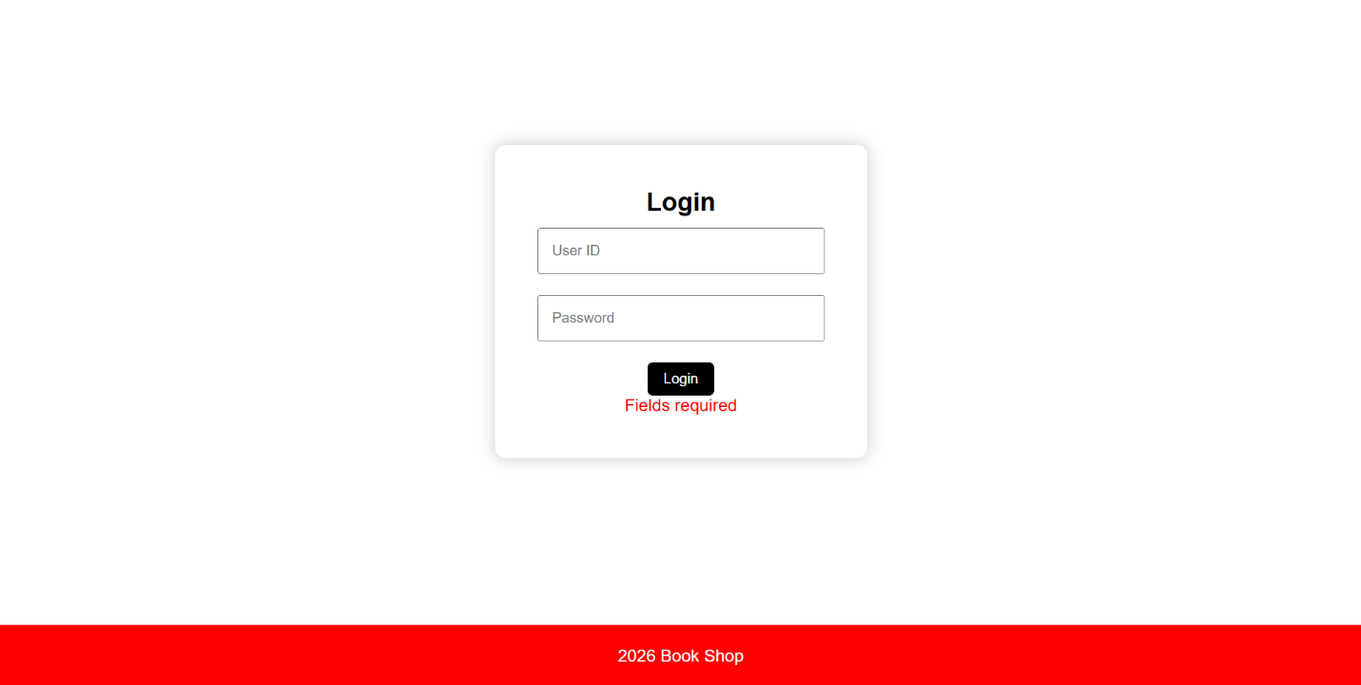
Output Screenshots

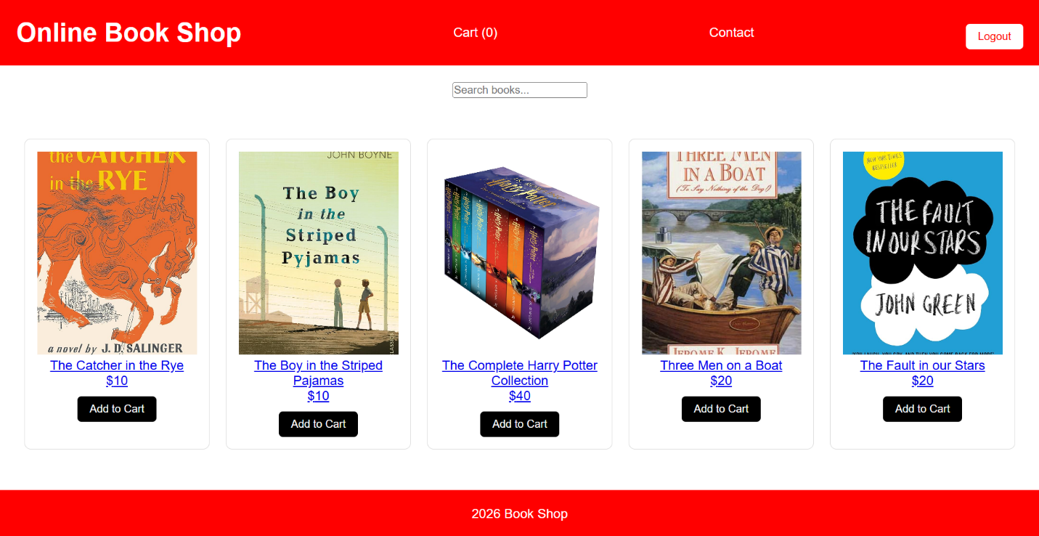
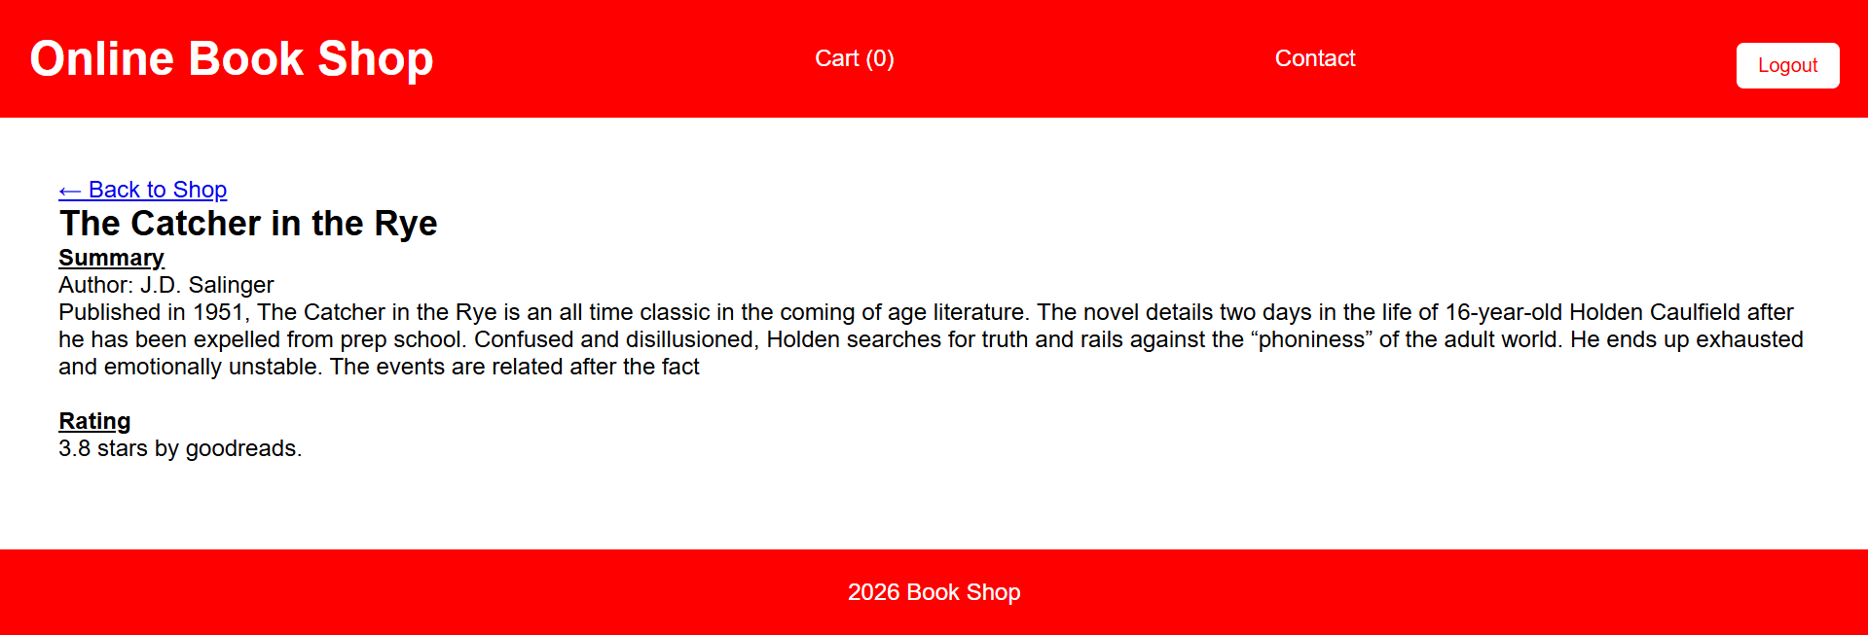
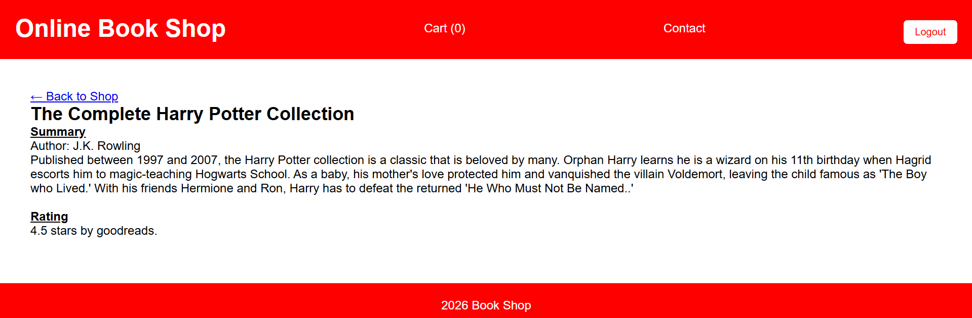
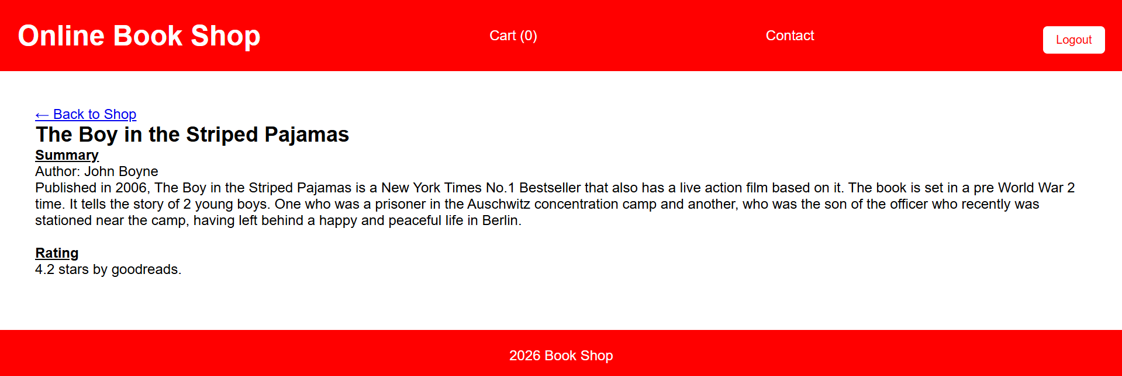
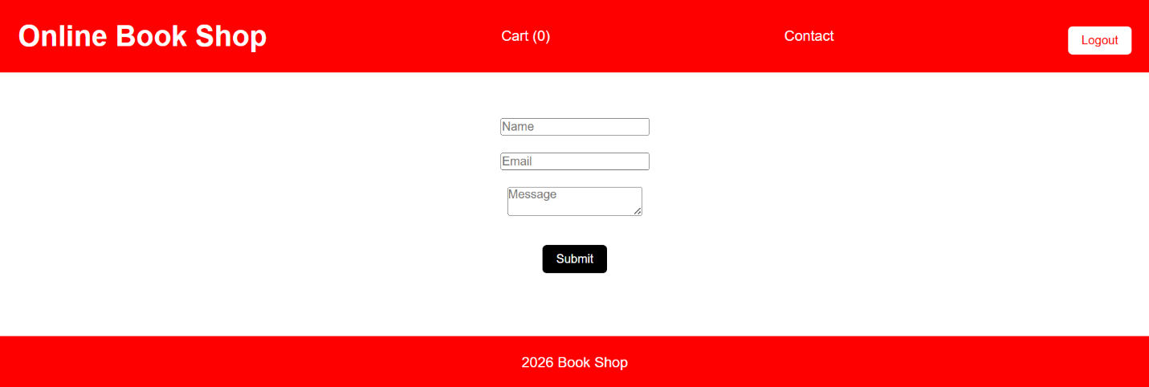
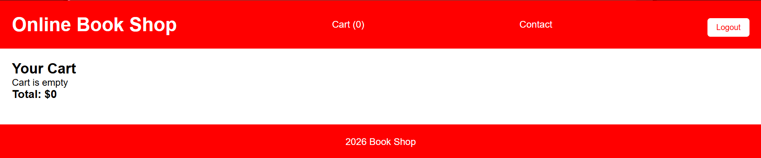
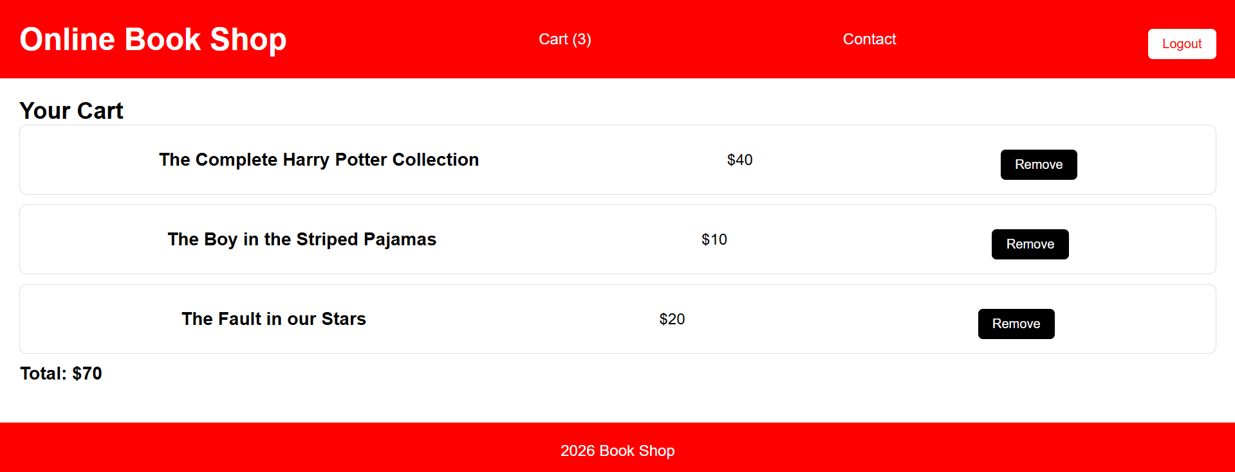
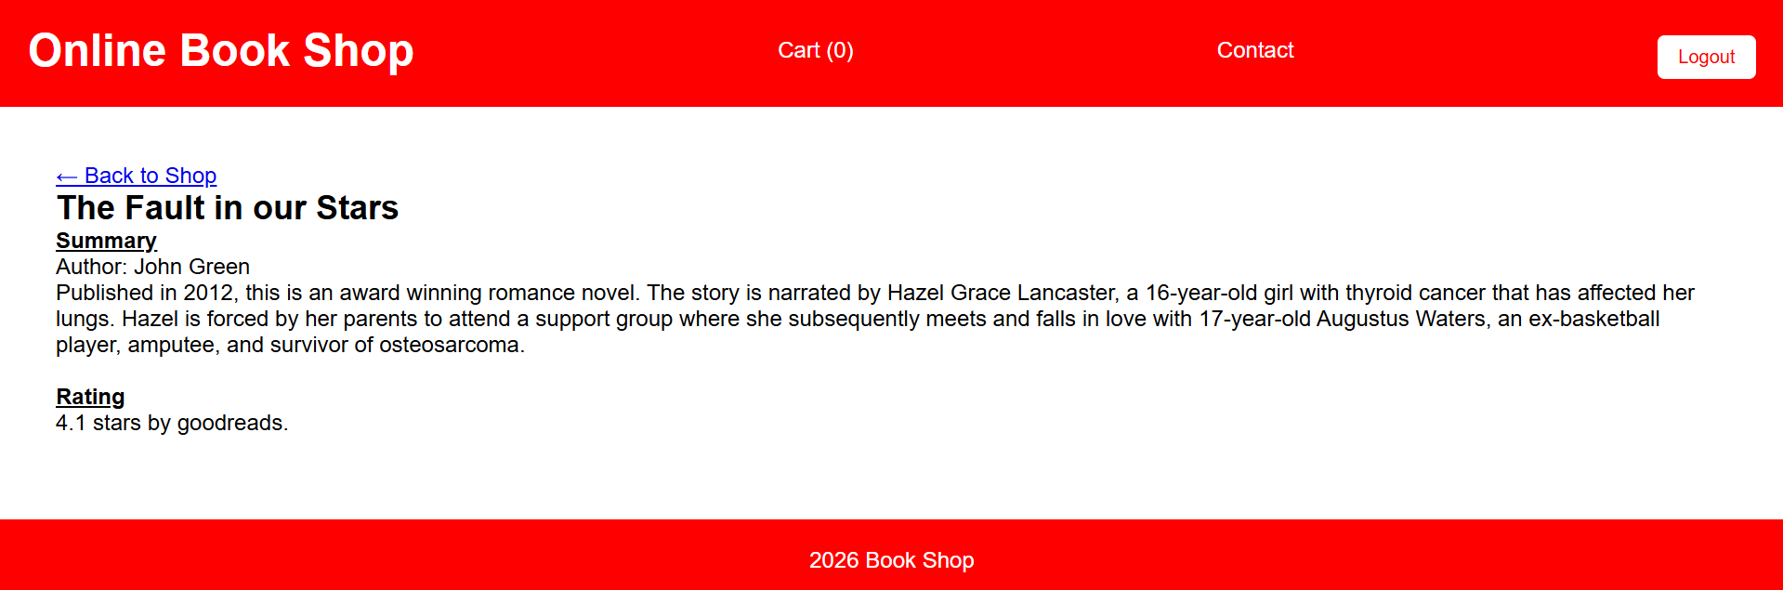
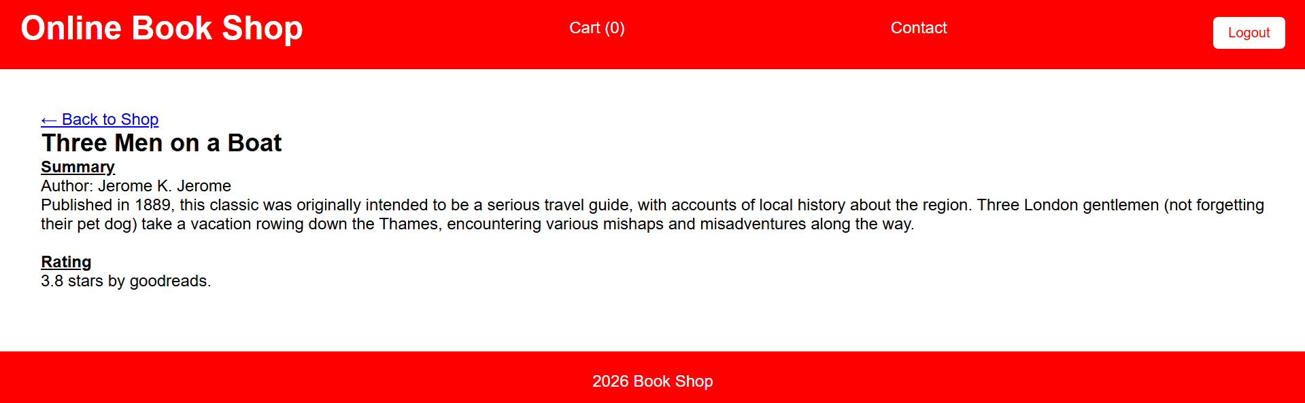
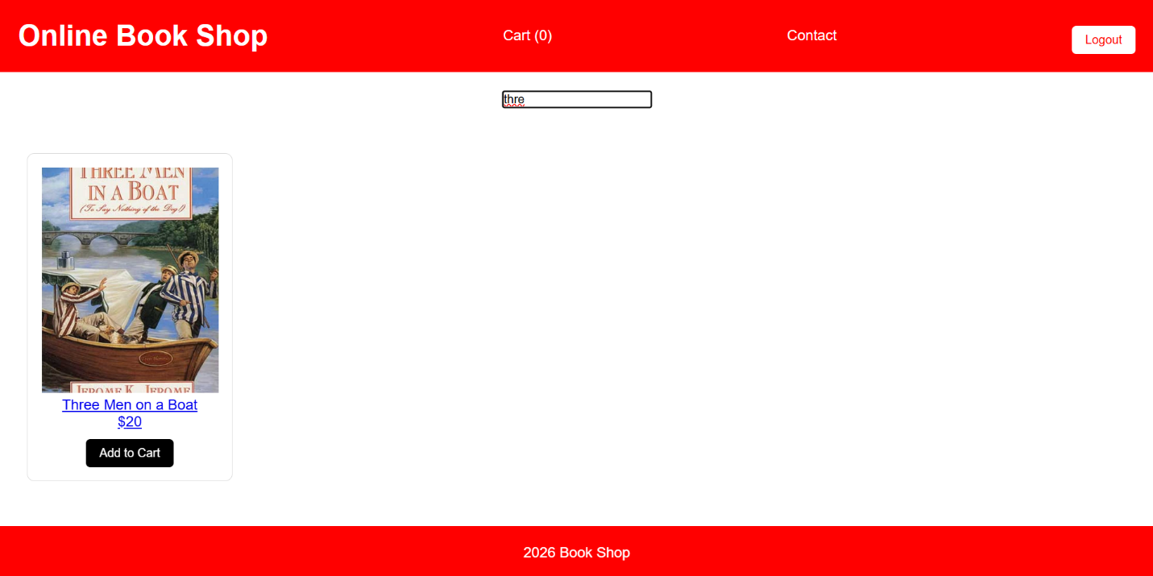
Conclusion
We had set out with a goal to build a website that can be used to browse books, view their details and add them to cart. We have accomplished the same. The desired web pages were initially obtained after coding in HTML and JS, with experimentation in CSS for the appropriate colors and sizes. Later, they were converted to a React application.
Limitation
- There are only a limited number of books
- No way to add to cart from the book page
Future Work
- Implement way to add books to cart from the book page
- Optimize so that specified count of each book can be added to cart
- Implement with a payment terminal to be able to checkout and pay for books
References
- Class slides
- GeeksforGeeks
- W3schools

